Lab 02 - .NET - Dev - Autoscaling the web app by using custom metrics
Estimated Duration: 15 minutes
Lab Type: Instructor led
Objective:
This lab describes how to set up autoscale for a web app by using one of the Application Insights metrics to scale the web app in and out from the Azure portal. Autoscale allows you to add and remove resources to handle increases and decreases in load.
more...

Exercise 1: Configure autoscale
Configure the autoscale settings for your App Service plan.
- From the Home page of the Azure portal(https://portal.azure.com), search for and select autoscale.
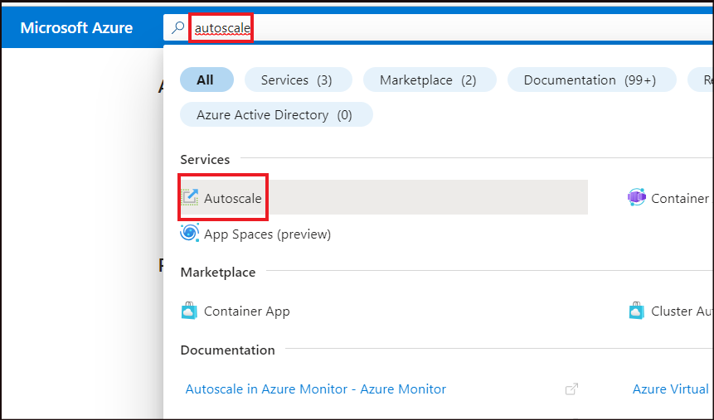
- Select myAppServicePlan.
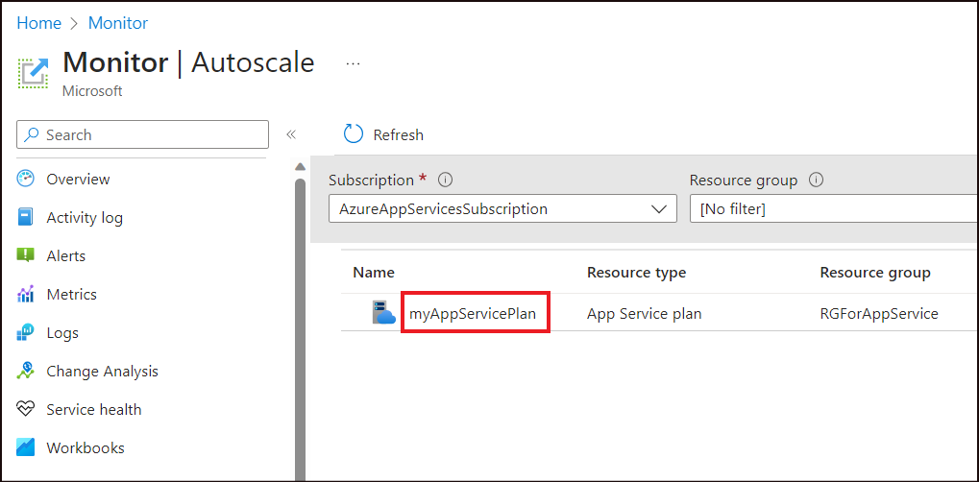

Task 1: Set up a scale-out rule
Set up a scale-out rule so that Azure spins up another instance of the web app when your web app is handling more than 70 sessions per instance.
- Select Custom autoscale.
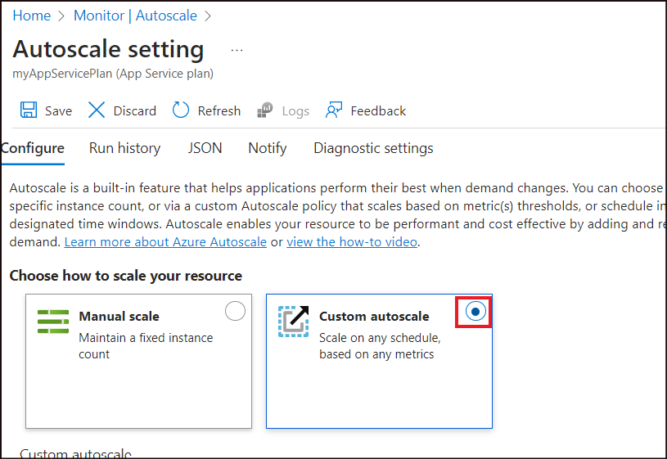
- In the Rules section of the default scale condition, select Scale based on a metric and click on Add a rule.
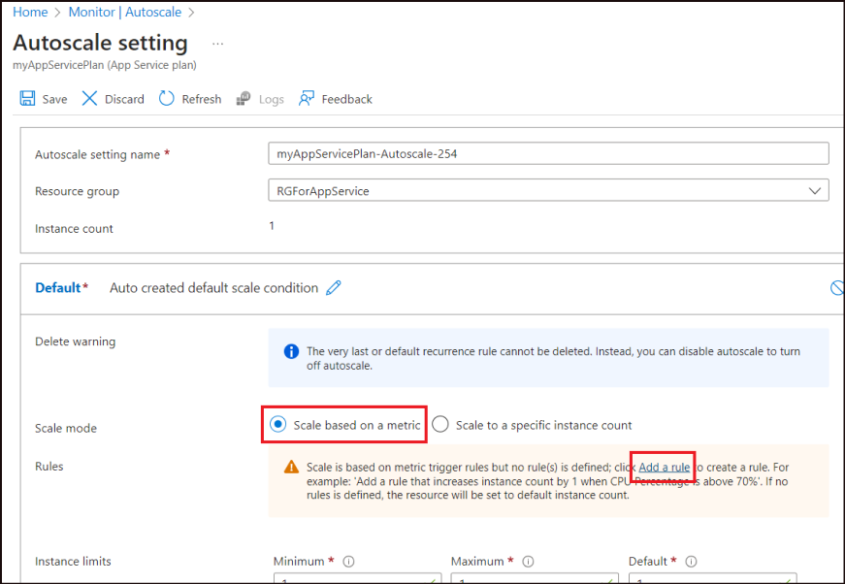
- Enter the below details and then click on Add.
Property | Value
Metric source | Other resource
Resource type | Application Insights
Resource | Select your app name
Metric namespace | Log-based metrics
Metric name | Sessions
Enable metric divide by instance count | Enable
Operator | Greater than
Metric threshold to trigger the scale action | 70
Action -> Operation | Increase count by
Instance count | 1
- 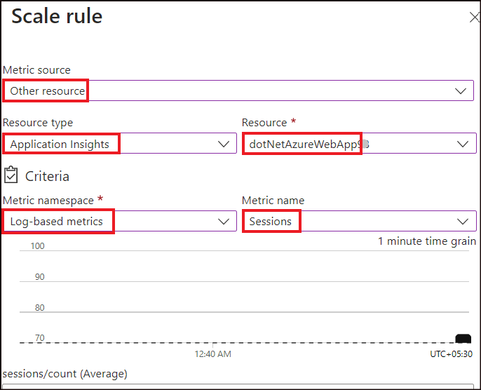
- 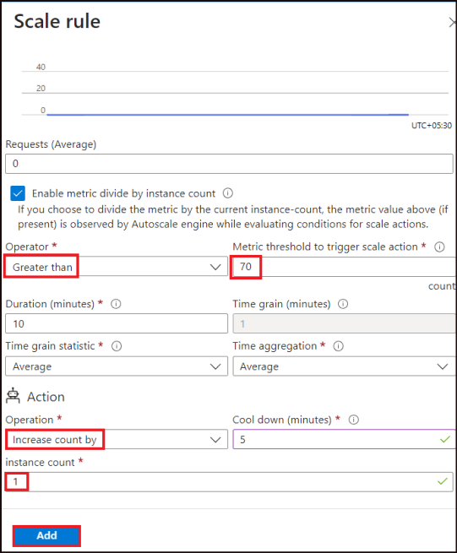

Task 2: Set up a scale-in rule
Set up a scale-in rule so that Azure spins down one of the instances when the number of sessions your web app is handling is less than 60 per instance. Azure reduces the number of instances each time this rule is run until the minimum number of instances is reached.
- In the Rules section of the default scale condition, select Add a rule.
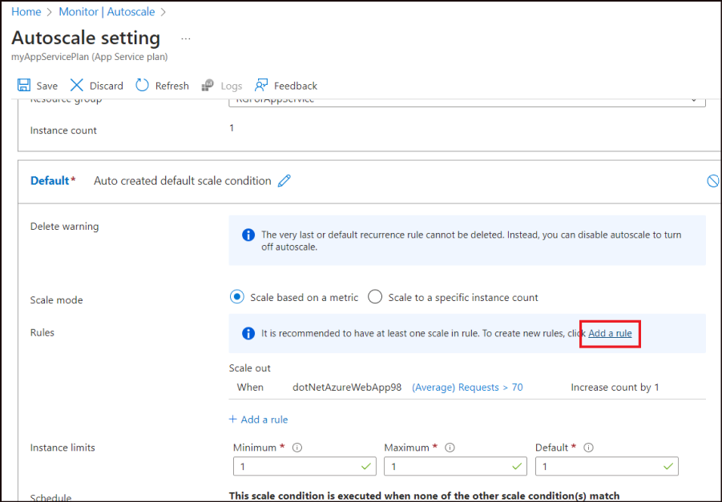
- Enter the below details.
Property | Value
Metric source | Other resource
Resource type | Application Insights
Resource | Select your app name
Metric namespace | Log-based metrics
Metric name | Sessions
Enable metric divide by instance count | Enable
Operator | Less than
Metric threshold to trigger the scale action | 60
Action -> Operation | Decrease count by
Instance count | 1
- Select Add.
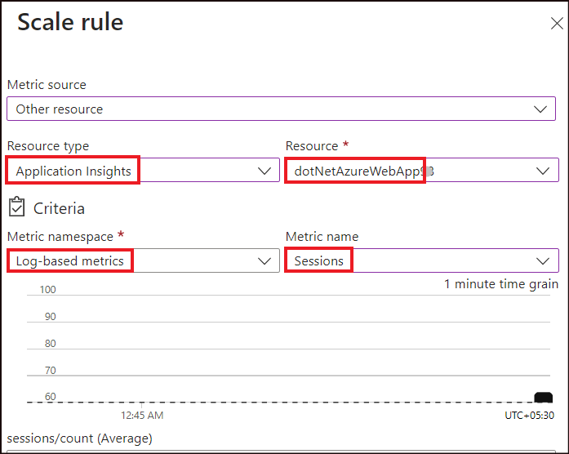
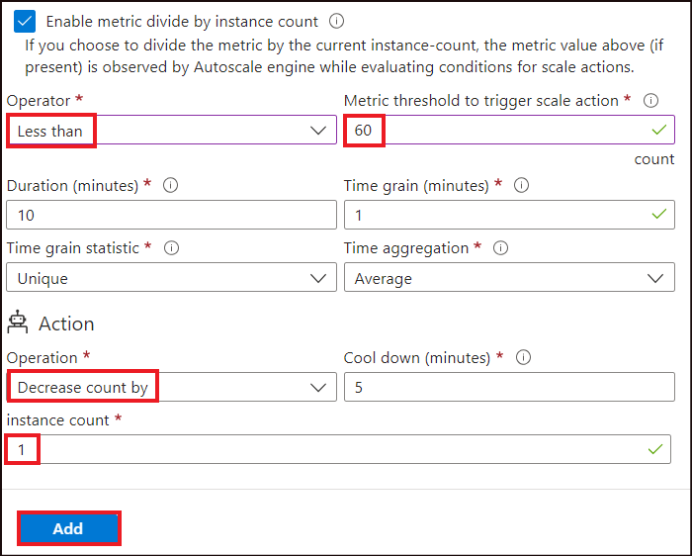

Task 3: Limit the number of instances
- Set the maximum number of instances that can be spun up in the Maximum field of the Instance limits section to be 4.
- Select Save.
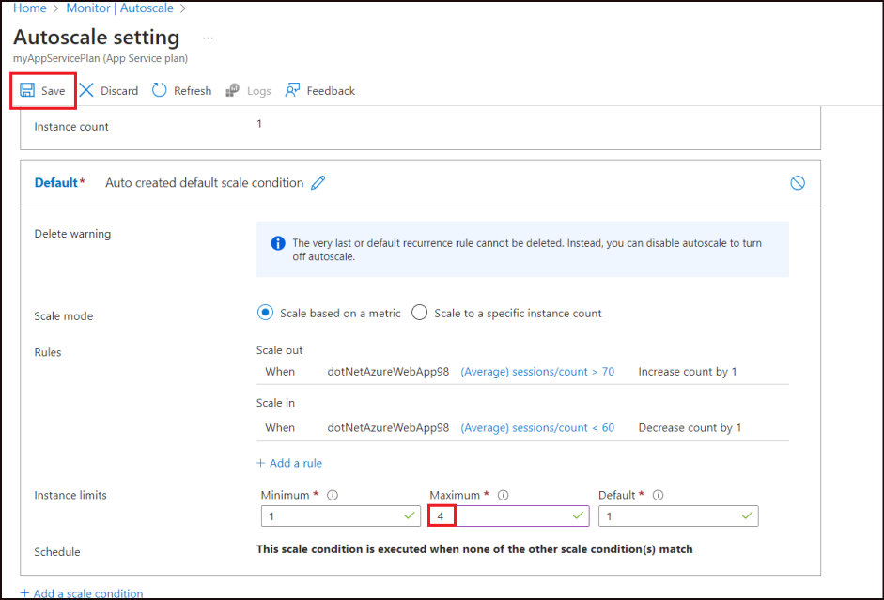
- A success message stating that the configuration has been updated is notified.
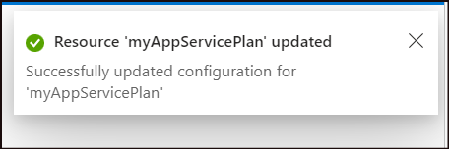

Exercise 2: Clean up resources
- From the Azure portal, open the web app, dotNetAzureWebApp99 page. Click on Delete.
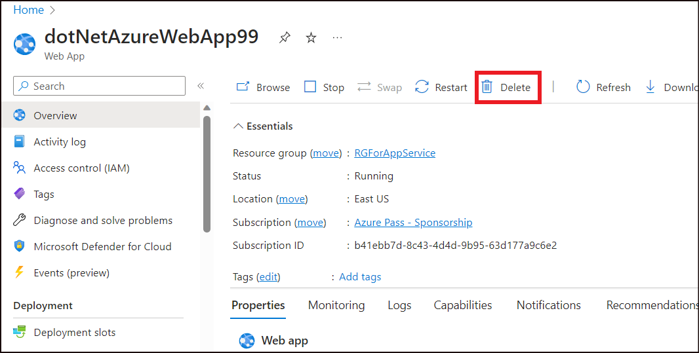
- Enter the web app name, dotNetAzureWebApp99 (The random number to be replaced with the one you had used while creation), to confirm the deletion and then click on Delete.
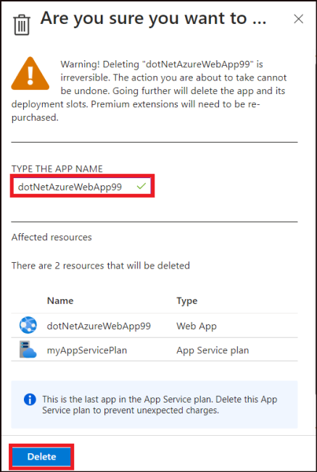
- A success message is obtained once the App is deleted.
- From the Azure portal home page, select Resource groups and then select the Resource Group RGForAppService.
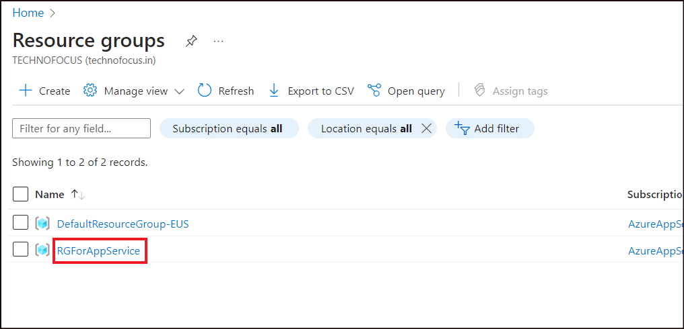
- On the Resource Group page, select Delete resource group.
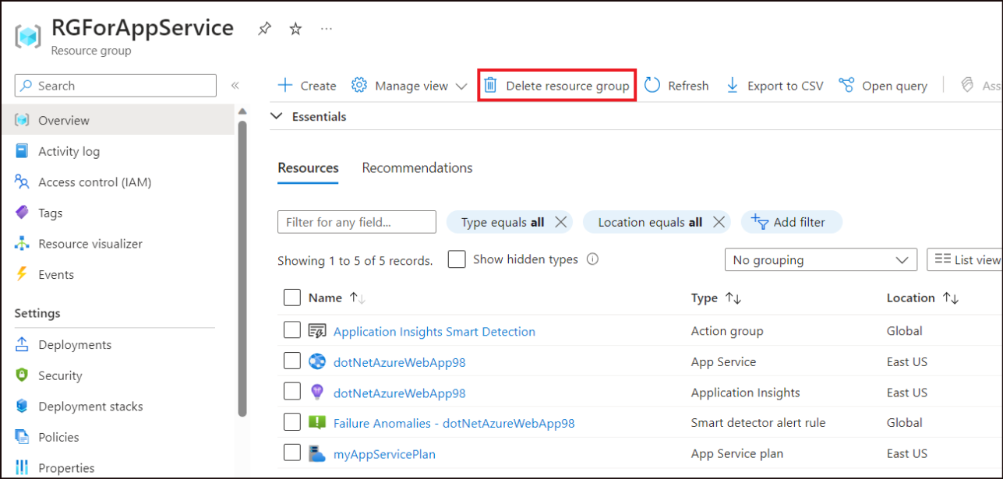
- Type in the Resource group name, RGForAppService in the text box and then click on Delete.
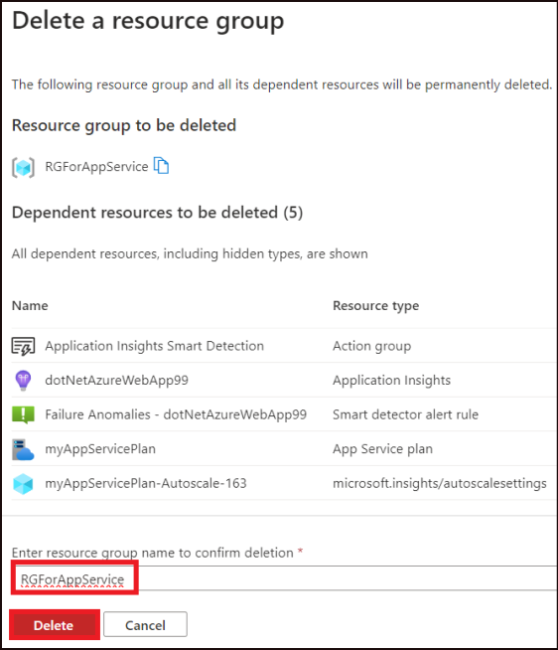
- Click on Delete on the confirmation box.
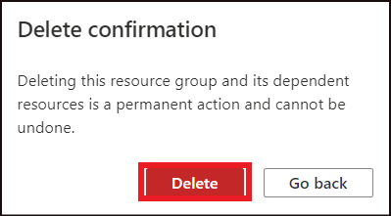
- A success message for deletion of the Resource group is notified.
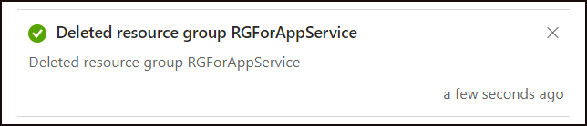
Summary:
In this lab, you have learnt on how to perform auto scaling on a web app deployed in Azure.

